**Practical No. 3**

**Aim:** To implement aggregate functions.

**Theory:**

Aggregate functions are essential tools in database management systems (DBMS) used to perform calculations on sets of values, often within a specified column or result set. These functions provide valuable insights into data and enable users to extract meaningful summaries. In this theory, we will explore the implementation of aggregate functions and their significance in database operations. Some of the aggregate functions are:

COUNT = count the number of rows that match a specific condition

MIN = fetch the minimum value from a column

MAX = fetch the maximum value from a column

SUM = calculates the sum of numeric values in a column

AVG = calculates the average of numeric values in a column

**Queries:**

1) COUNT():

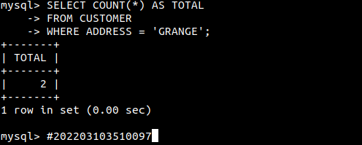

2) MIN():

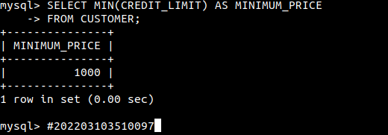

3) MAX():

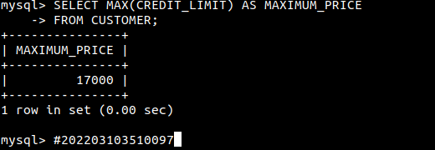

4) SUM():

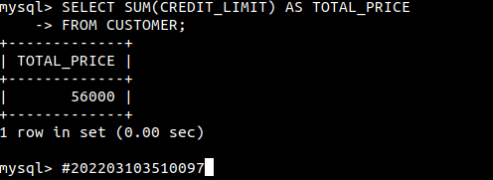

5) AVG():

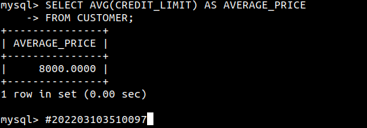

**Conclusion:** Aggregate functions are powerful tools for analyzing and summarizing data in a database. They allow users to derive insights, make data-driven decisions, and extract valuable information from large datasets. By understanding the types of aggregate functions available and how to use them in SQL queries, database professionals can harness the full potential of their data for reporting and decision-making purposes.